
Lesson Plan: The Sculptor’s Journey
Grade Level: K–6 | Subject: Choice-Based Ceramics (Pinch Pots)
l. National & New Mexico Core Arts Standards (NCAS/NMCAS)
The following standards are applied across the K–6 spectrum, with increasing complexity in the "Elaborate" phase:
VA:Cr1.1 (Creating - Investigate/Plan/Make): * NM Emphasis: Generate and conceptualize artistic ideas by connecting them to personal or local New Mexico environments (e.g., using the "Naturalist" corner to discuss high-desert textures).
VA:Cr2.2 (Creating - Investigate): * NM Emphasis: Demonstrate safe and proper procedures for using clay tools and kilns. Ensure "Quality Craftsmanship" is treated as a form of respect for the material and the community.
VA:Cn11.1 (Connecting): * NM Emphasis: Relate artistic ideas and works with societal, cultural, and historical context to deepen understanding. (Connecting the "Pinch Pot" to the long history of pueblo pottery in New Mexico).
II. Bloom’s Taxonomy Objectives
By the end of this lesson, students will be able to:
- Cognitive (Synthesis/Create): Design a unique ceramic vessel that translates a 2D inspiration from the 4-Corners activity into a 3D form.
- Psychomotor (Mechanism/Guided Response): Construct a structurally sound pinch pot with consistent wall thickness and secure "Score & Slip" attachments.
- Affective (Valuing/Organizing): Defend their aesthetic choices during the 4-Corners
reflection and peer-review process.
III. The 5E Instructional Model
(1)ENGAGE (The 4-Corners Hook)
Introduce the four "Inquiry Corners" (Naturalist, Architect, Storyteller, Abstractist). Students move to the corner that matches their "Artist Persona" for the day.
Corner 1 (The Naturalist): Organic shapes (nests, seed pods, shells).
Corner 2 (The Architect): Geometric, structured, or symmetrical vessels.
Corner 3 (The Storyteller): Pinch pots transformed into characters or animals.
Corner 4 (The Abstractist): Texture-heavy, non-functional, "rule-breaking" forms.
Ask: "How does the texture in this corner make you feel? How would you hold this if it were made of clay?"

(2)EXPLORE (Material Play)
Students receive a "golf ball" size of clay. Without a formal demo yet, they are asked to "find the center" and see how deep they can push their thumb without going through the bottom.
Focus: Discovering the clay's physical limits (The "Aha!" moment of the material).
(3)EXPLAIN (The Technical "Why")
The teacher facilitates a "Facilitator-Led" demo based on the scaffolded levels (K-1 Simple, 2-4 Functional, 5-6 Complex).
Key Concepts: Centering, Butterfly Pinching, Rim Smoothing, and the "Score, Slip, Press, Smooth" method for attachments.

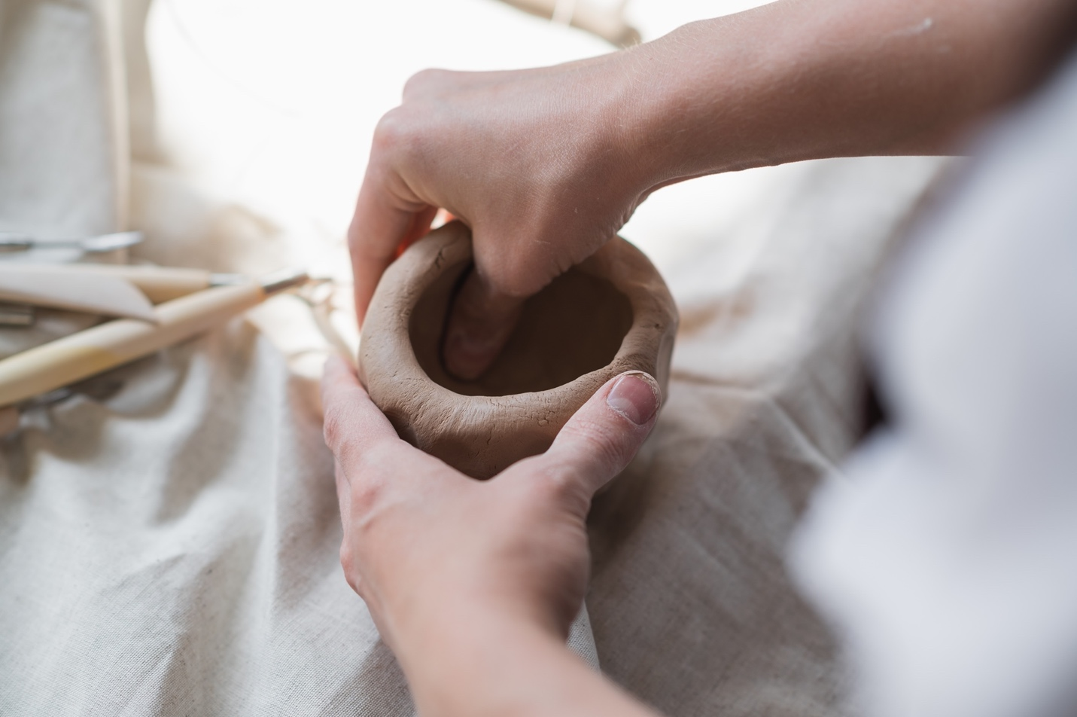

(4)ELABORATE (The Sculptor’s Journey)
Students return to their "Corner" inspiration and begin their final build.
K–1: Focus on the "Seed" pot (smoothness and shape).
Focus: Fine motor skills and uniform wall thickness.
Task: Create a simple, rounded sphere. Use the "thumb-press and "butterfly-pinch" (using pointer finger and thumb) to create a small bowl.
Challenge: Can you make the rim as smooth as a river stone?
2–4: Focus on adding a functional handle or footed base.
Focus: Height, stability, and "Score & Slip" attachments.
Task: Create a deeper pinch pot. Once the base is formed, students must add a "functional" element (a handle, a footed base, or a lid) using the Score, Slip, Press, and Smooth method.
Challenge: Can you manipulate the walls to be thin enough to be light, but thick enough to stand?
5–6: Focus on the "Double-Pinch" hollow form or intricate surface narrative.
Focus: Combined forms and surface Narrative.
Task: Double-Pinch Pot Construction. Students create two identical pinch pots and join them at the rims to create a hollow "egg" or "orb." They then cut into the form or add external sculptural elements.
Challenge: Transform the hollow form into a creature or a complex geometric sculpture.
(5)EVALUATE (Self-Reflection & Rubric)
Students use the provided rubric to grade their own work before the "Gallery Walk."
Exit Ticket: "One thing I learned about my 'Corner' style today was..."
Tiered Differentiation Strategy
1. The "Advanced" Tier (Gifted & Talented / High Mastery)
Focus: Complexity, Conceptual Depth, and Technical Precision
The Challenge: Double-Pinch Pot Construction. Instead of one vessel, these students must create two matching pinch pots and "weld" them together to create a hollow sphere or "egg."
Technical Goal: They must incorporate a "vent hole" (to prevent explosion in the kiln) disguised as a sculptural element.
Cognitive Extension: Ask them to incorporate Metaphor. "If your vessel represents a 'Corner' style, how can you change its shape to represent an emotion?"
Standard: VA:Cr3.1.6a (Refining and completing artistic work).
2. The "Regular" Tier (Grade Level Mastery)
Focus: Structural Integrity and Functional Addition
The Challenge: The Modified Vessel. Students create a standard pinch pot but must add at least two "attachments" (a handle, a foot, or decorative sprigs).
Technical Goal: Master the Score, Slip, Press, Smooth technique to ensure no pieces fall off during the drying process.
Cognitive Extension: Focus on Symmetry. "Can you make the left side of your vessel a mirror image of the right?"
Standard: VA:Cr2.1.4a (Demonstrating quality craftsmanship).
3. The "Low/Support" Tier (Emerging Skills / IEP / Sensory Needs)
Focus: Fine Motor Success and Basic Form
The Challenge: The "Seed" Bowl. Focus entirely on the "Butterfly Pinch" and maintaining a "Goldilocks" thickness (not too thin, not too thick).
Support Tools: Provide Pinch-Pot Templates (small wooden spheres or balls) for students to mold around if they struggle with manual "centering."
Sensory Modification: If a student is sensitive to the "dry" feeling of clay, provide a small sponge and extra slip to keep the surface "creamy" and manageable.
Standard: VA:Cr2.2.Ka (Identifying and using art tools safely).

RUBRICS

Criteria | Advanced  (4) | Proficient  (3) | Emerging  (2) | Novice  (1) | Score
Technical (Psychomotor) | Refined, thin walls; expert joins. | Even walls; secure attachments. | Uneven walls; basic scoring. | Unstable walls; no scoring.
Concepts (Cognitive) | Innovative, complex design. | Integrated "Corner" inspiration. | Followed basic steps only. | No clear design plans.
Engagement (Affective) | Articulated deep aesthetic choice. | Shared ideas with peers. | Participated in 4-Corners. | Disconnected from process.
Craftsmanship | Professional "Gallery-ready" finish. | Clean edges; smooth finish. | Visible cracks/debris. | Unfinished/unstable.
Overall Total Score

Prepared By:

Rodney King Lisondra, MAEd. (SGT.)
Art Teacher/Educator/Leader
Mesa View Elementary
Grants Cibola County Schools
Grants, New Mexico, USA 87020

